# Lab-3: Maltego

Sumera.

Screenshot 1: In this NS operation is run.

In result for server name 6 results are shown as output for linkedin.com.

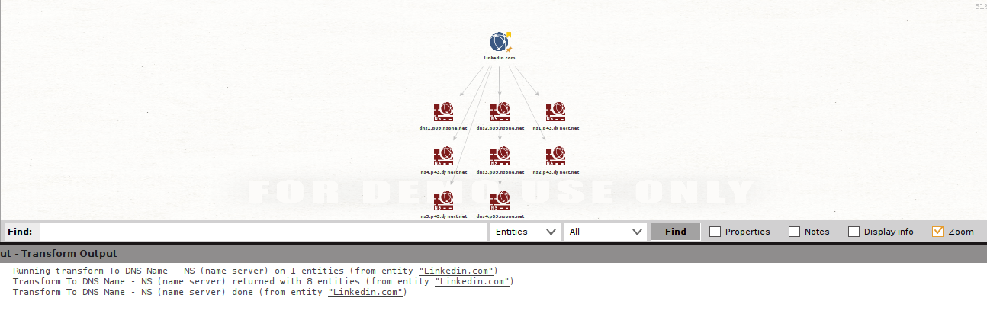

Screenshot 2: In this MX mail server operation is performed.

Mail servers for linkedin.com are shown in following screenshot.

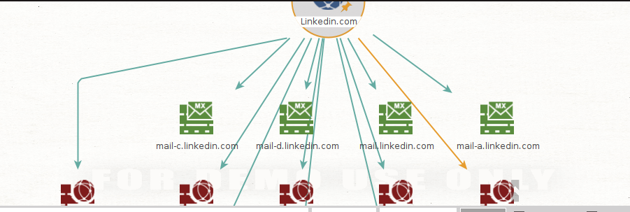

Screenshot 3: the operation here performed is DNS SOA (start of authority), its specify the Administrative information about a zone.

In this screenshot SOA are shown for linkedin.com.

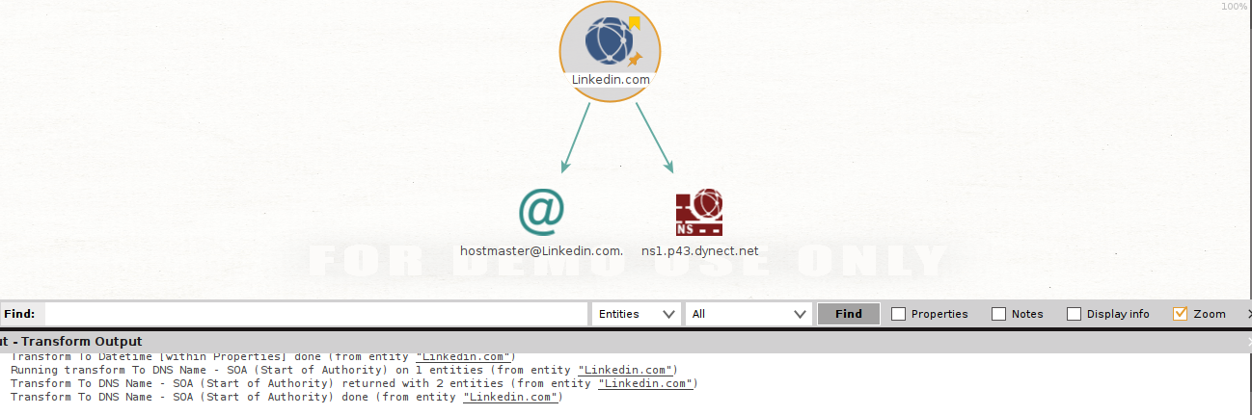

Screenshot 4: In this operation is performed to view SPF (sender policy framework), it is used to view all the email servers that have permission to send the email on your or owners behalf or using the domain.

SPF for linkedin.com are shown in screenshot below.

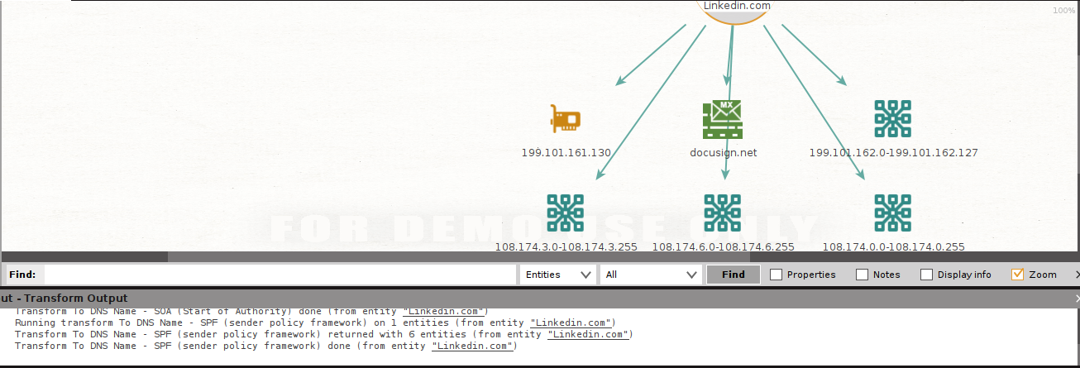

Screenshot 5: There the zone transfer operation is performed, that is use to create a read-only copy of primary information of DNS.

Following screenshot show no result for zone-transfer for linkedin.com.

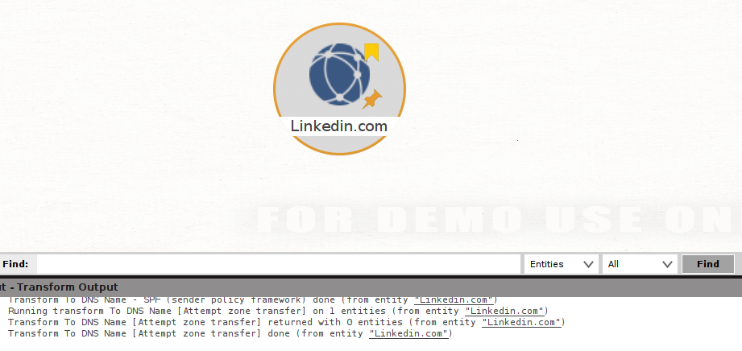

Screenshot 6: Operation for DNS name is performed; this operation is performed to view common DNS name for targeted domain.

In this screenshot common DNS are shown for linkedin.com.

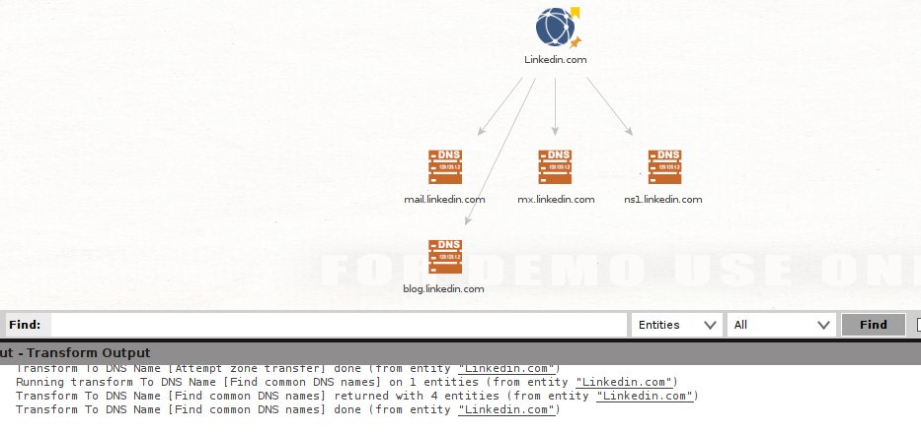

Screenshot 7: operation for Name Schema Dictionary is performed; this is performed to view all the specific server schema and their specific use.

Name schema dictionary for linkedin.com can be viewed in screenshot.

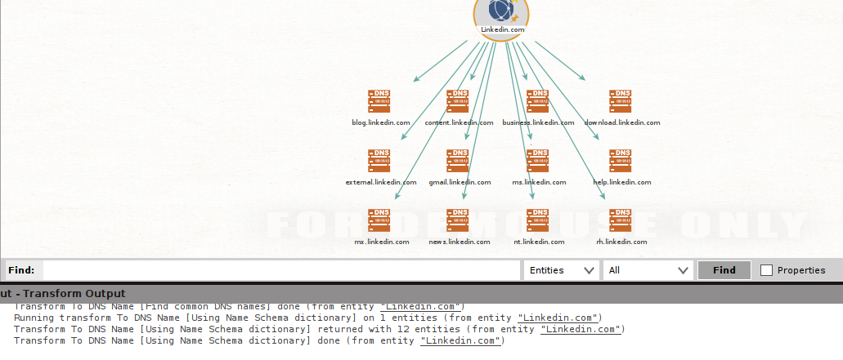

Screenshot 8: The operation is performed for different TLD of targeted domain.

In below different TLDs for linkedin.com are shown.

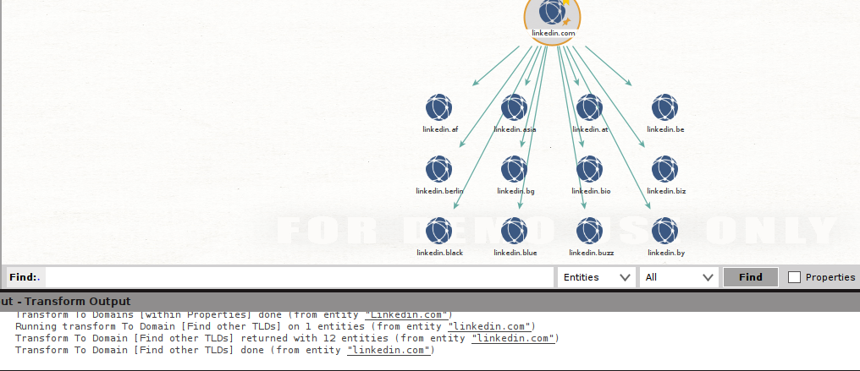

Screenshot 9: Operate to view email @domain, that is the email contain by domain.

Email @domain for linkedin.com is shown below.

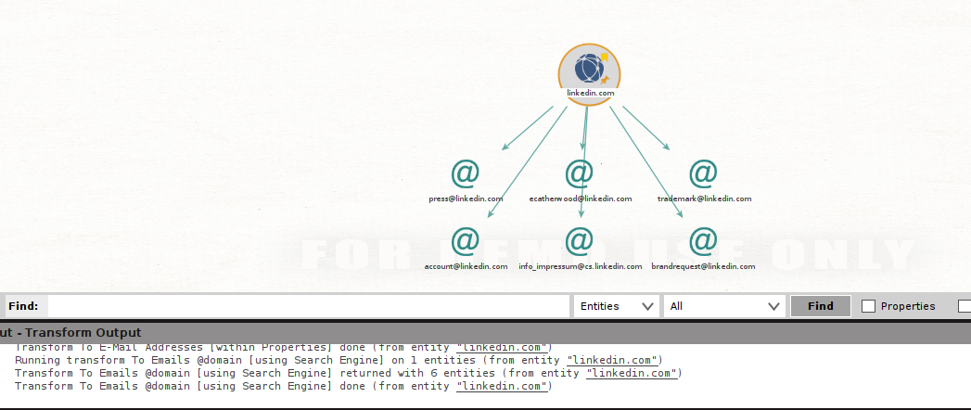

Screenshot 10: Operation for Domain Name is performed using Robtex database, this database contains data about almost all domain on internet.

In screenshot below the result for linkedin.com is shown using the Robtex database.

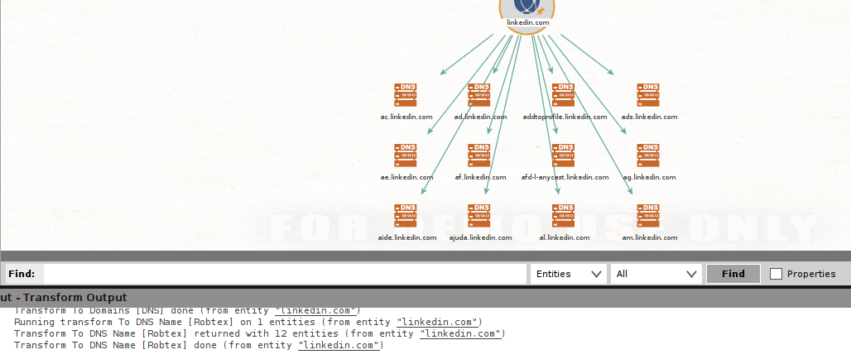

Screenshot 11: transform to email addressing using whois information.

Result for linkedin is shown below.

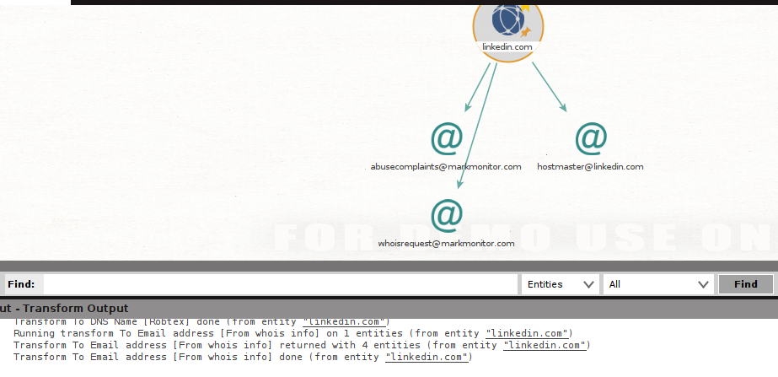

Screenshot 12: this operation works on PGP key to extract information.

Result for PGP key for linkedin.com is shown below.

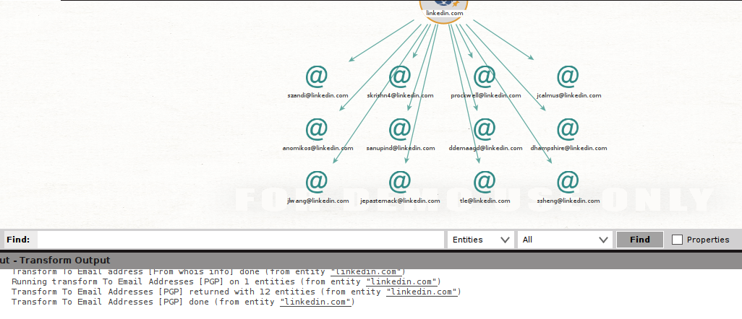

Screenshot 13: Finding email address using search engine.

For linkedin.com is shown below.

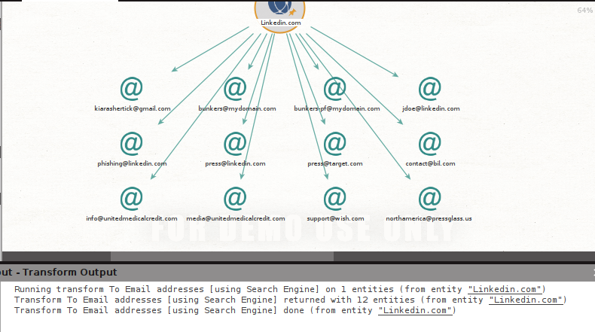

Screenshot 14: finding of entities of targeted domain from WHOIS.

Entities for linkedin.com is shown below.

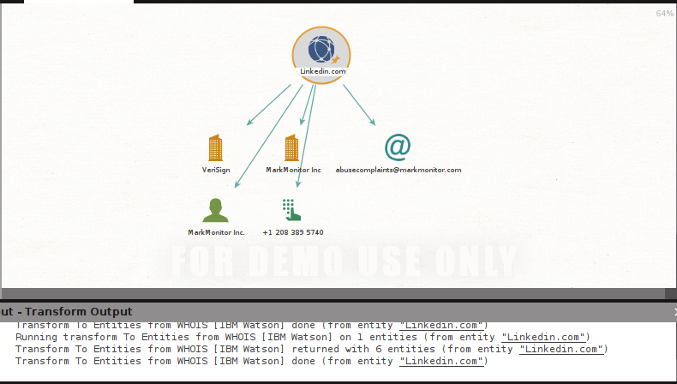

Screenshot 15: operation to find files using search engine.

Linked.com files available on internet.

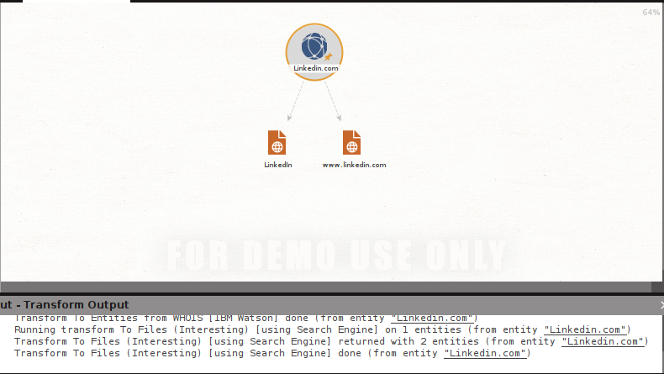

Screenshot 16: operation to find files (office) using search engine.

Below are files (office) for linkedin.com.

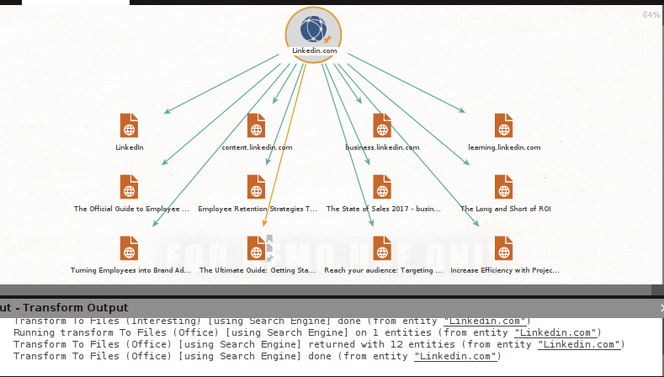

Screenshot 17: Operation to find person using PGP.

Results for linkedin.com domain are shown below.

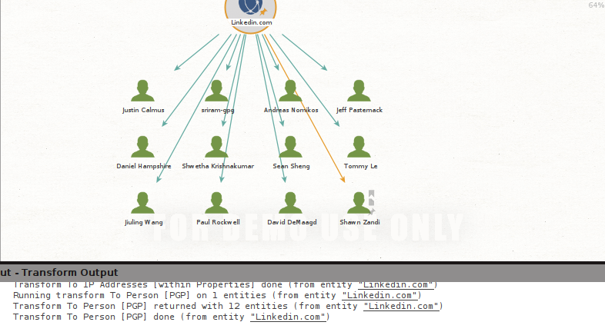

Screenshot 18: This operation is performed to view phone no.’s related to domain.

Phone no.’s for linkedin.com are shown in screenshot.

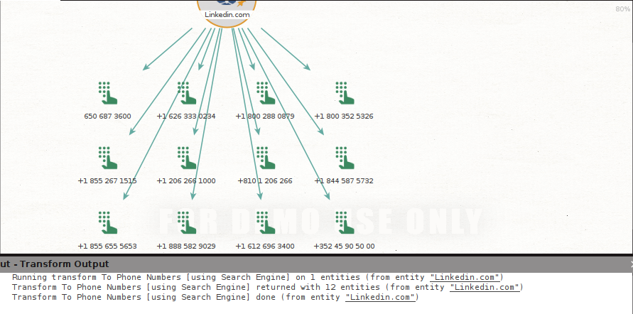

Screenshot 19: This operation is used to view snapshot (Wayback Machine), it’s a tool to see how targeted domain looked back in time.

Results for linkedin.com are shown in screenshot.

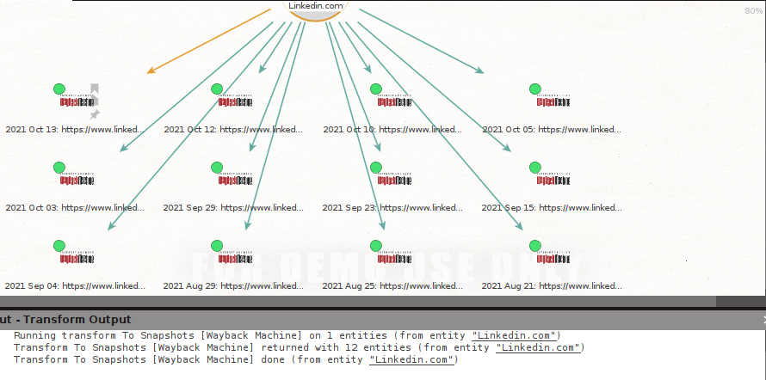

Screenshot 20: this operation is use for viewing the website of targeted domain.

Results for linkedin.com are shown below.

